Self-Care As A Professional Practice Skill

Becoming a lawyer involves developing knowledge, skill and judgement plus the ability to apply all of these toward successful outcomes for clients consistently ongoing. This is a tall order when we consider that the legal profession is one of the most demanding, rigorous and exhausting.

The practice of law is often perceived as “high-prestige, high-income, high-skill and high-stress profession” (Rothstein, 2008). The professional culture is often highly competitive where self-sufficiency is valued and work conditions are isolated and isolating. Lawyers suffer higher rates of burnout, mental health challenges including addiction than social welfare and mental health professionals (Norton, Johnson & Woods, 2016).

This session will offer a framework for planning and engaging in self-care actions to proactively build skills that align with the Law Society of Ontario’s personal management guidelines for lawyers.

The Personal Management Guideline from the Law Society of Ontario assists lawyers in recognizing indicia of mental illness and addictions as well as sources of stress in the legal profession and provides basic suggestions, strategies, supports and resources to manage personal well-being. https://lso.ca/lawyers/practice-supports-and-resources/practice-management-guidelines/personal-management
U of T My SSP provides students with real-time and/or appointment-based confidential, 24-hour support for any school, health, or general life concern at no cost to you. You can call or chat with a counsellor directly from your phone whenever, wherever you are in 146 languages. https://studentlife.utoronto.ca/service/myssp/
Access to the University of Toronto Virtual Fitness is FREE for incidental fee-paying students enrolled in winter courses at U of T. All you have to do is register! You can register for the whole semester or for a monthly pass. https://www.utrain.utoronto.ca/

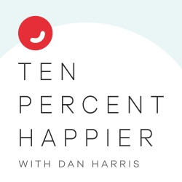
10% Happier is a mindfulness podcast hosted by Dan Harris, a bestselling author of a book with the same name. The podcast addresses a clear, simple approach to meditation. It is great for skeptics, and created to help listeners keep it going. https://www.tenpercent.com/podcast/

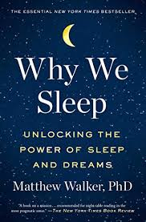
Neuroscientist and sleep expert Matthew Walker takes us on a fascinating and indispensable journey into the latest understandings of the science of sleep. The book goes way beyond satisfying intellectual curiosity, as it explores the cognitive, health, safety and professional consequences of compromising the quality and quantity of our sleep.

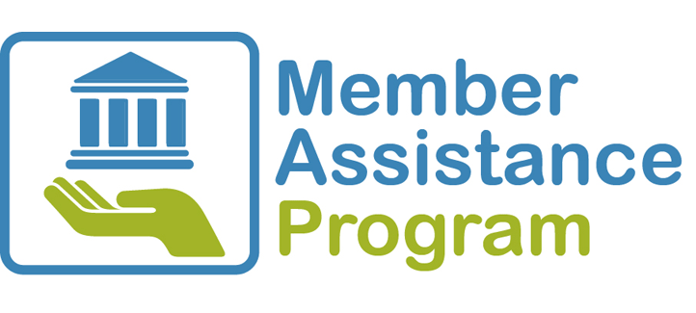
The Member Assistance Program (MAP) is a confidential service funded by and fully independent of the Law Society of Ontario and LawPRO. MAP provides secure, single sign-on or telephone access to counselling, coaching, online resources and peer volunteers. Members can get professional help with issues related to addictions, mental or physical health, work-life balance, career, family and more. https://www.homewoodhumansolutions.com/MSA/lawsocietyuppercanada

PHYSICAL
-
-
-
-

MENTAL
-
-
-
-

Name ____________________
Partner ___________________
Email _____________________

SPIRITUAL
-
-
-
-
EMOTIONAL
-
-
-
-

